**The Mill Restaurant**

Figart, Dunfanaghy

Tel: 0749136985

www.themillrestaurant.com

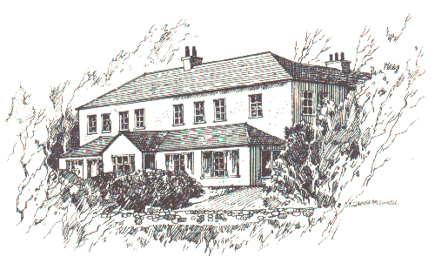

**To Begin**

Horn Head Crab

*Horn Head crab with avocado and sweetcorn sorbet.*

Irish Chicken

*Roast lemon and garlic Free range chicken with sweet pepper risotto and a tarragon emulsion.*

Pork

*Slow cooked crispy pork belly with taboulet and soy sauce.*

Soup

*Roast butternut squash and parmesan soup.*

Oysters

*Crispy oysters with homemade linguini and a lemon butter sauce.*

**Something refreshing**

Pink Grapefruit and gin sorbet

**To Follow**

Monaghan Duck

*Roast breast of duck with crispy confit leg, rosti potatoes, aubergine and sultana gravy*

Greencastle Turbot

*Pan fried Greencastle Turbot with tartare mash and cardamom sauce.*

Greencastle Pollock

*Panfried Pollock with home made tagliatelle, buttered leeks, fried anchovies and a chive butter sauce.*

Ravioli

*Ravioli with butternut squash, goats cheese and sage butter.*

Beef

*Pan fried rib-eye steak with wild mushrooms, béarnaise sauce and celeriac chips.*

*Side Orders: mixed leaves, champ, fat chips, €3.00 each*

**Price €43.50**

Something Sweet

Trio of Rhubarb, rhubarb crumble, rhubarb ice cream & rhubarb brulee.

Doughnuts with apple filling and a bitter chocolate sauce.

Pear tarte tatin with Crozier blue ice cream.

Selection of homemade ice creams with brandy snap.

A plate of Irish cheeses with onion marmalade.

Dessert Wines

Late Harvest ,made from Sauvignon Blanc the result is a complex taste of honey and mature fruit. €4.00 per glass

Muscat De Beaume De Venise, Muscat grape with flavours of flowers, tropical fruit & honey €4.00 per glass

ChateauFilhot,Sauternes A lovely rich Sauternes, full of honey flavours and crisp, white fruits. Deliciously rich and smooth!  €8.00 per glass

The Noble, Riesling grape full of fruit flavours, citrus, lime &pineapple.

With a clean acidic finish. €4.00 per glass

Port

Grahams Late bottled vintage port…..€4.10 per glass

Tea Forte Indulge in one of our special teas….€2.50 per pot

African solstice , a fruity cup with a hint of vanilla.

Chamomile tisane, shades of citrus and vanilla.

Citrus mint, The perfect finale to every sumptuous dining experience.

Ginger, bold and enticing with a lively character only fine ginger can import.

Green Tango, deliciously fragrant mango scents from this lightly steamed green tea.

**Chefs Food Suppliers**

**Derek Alcorn Killult Organic Centre, Falcarragh**

**Billie McQuaid Stephen Kerr, Butcher, Falcarragh**

**Marion McGrenra Albatross Seafood, Killybegs**

**(pastry chef and baker) Ivan McElhinney,Shellfish, Dunfanaghy**